## TABLE OF CONTENTS

|  |  |  |
| --- | --- | --- |
| **CHAPTER**  **NO.** | **TITLE** | **PAGE NO.** |
| **1** | **INTRODUCTION** |  |
|  | 1.1 Project Overview |  |
|  | 1.2 Purpose |  |
| 2 | **LITERATURE SURVEY** |  |
|  | 2.1 Existing Problem |  |
|  | 2.2 References |  |
|  | 2.3 Problem Definition Statement |  |
| **3** | **IDEATION & PROPOSED SOLUTION** |  |
|  | 3.1 Empathy Map Canvas |  |
|  | 3.2 Ideation & Brainstorming |  |
|  | 3.3 Proposed Solution |  |
|  | 3.4 Problem Solution Fit |  |
| **4** | **REQUIREMENTS ANALYSIS** |  |
|  | 4.1 Functional Requirement |  |
|  | 4.2 Non - Functional Requirement |  |

|  |  |  |
| --- | --- | --- |
| **5** | **PROJECT DESIGN** |  |
|  | 5.1 Data Flow Diagrams |  |
|  | 5.2 Solution & Technical Architecture |  |
|  | 5.3 User Stories | 16 |
| **6** | **PROJECT PLANNING & SCHEDULING** | 18 |
|  | 6.1 Sprint Planning & Estimation | 18 |
|  | 6.2 Sprint Delivery schedule | 19 |
|  | 6.3 Reports from JIRA | 20 |
| **7** | **CODING & SOLUTIONING** | 21 |
|  | 7.1 Feature 1 |  |
|  | 7.2 Features 2 |  |
|  | 7.3 Features 3 |  |
|  | 7.4 Features 4 |  |
|  | 7.5 Feature 5 | 21 |
| **8** | **TESTING** | 24 |
|  | 8.1 Test Cases | 25 |
|  | 8.2 User Acceptance Testing | 26 |
| **9** | **RESULTS** | 27 |
|  | 9.1 Performance Metrics | 28 |

|  |  |  |
| --- | --- | --- |
| **10** | **ADVANTAGES & DISADVANTANGES** | 30 |
| **11** | **CONCLUSION** | 31 |
| **12** | **FUTURE SCOPE** | 31 |
| **13** | **APPENDIX** | 32 |
|  | 13.1 Source Code | 32 |
|  | 13.2 Github & Demo link | 33 |
| **14** | **REFERENCE** |  |

* 1. **Project Overview**

# INTRODUCTION

Fuel efficiency is one of the quality indicators of transport vehicles. Fuel consumption is a significant part of the operating costs of a vehicle. Fuel consumption is the amount of fuel a vehicle uses to travel a particular distance.

Generally fuel consumption is the inverse of fuel economy. Therefore it is important to monitor fuel consumption. The fuel consumption prediction is one of the best ways to reduce the consumption. It helps users to be aware of vehicular conditions and manage the expenses accordingly. Since the increase in fuel rate has affected ordinary lives, it is essential to predict the consumption before use. In order to do this we have developed a model which enables users to predict the fuel consumption easily and accurately. The model has been developed using Machine Learning. The solution is a web application that has been integrated with the Machine learning model. Initially the user must register to the website and get authorized. Users can access the web application to get the prediction result by providing basic inputs such as distance, mileage, vehicle weight, speed, gas type and road type. The model developed takes input from the user and processes it with different algorithms of machine learning such as Multi linear regression, Ridge and Lasso. The web application serves two types of prediction which includes Single sample prediction for single vehicle and Multi sample prediction for number of vehicles. Multi sample prediction is aimed at users like organizations where vehicular use is large(eg. Transportation). The input data given by these organizations are usually large in volume. To make it easy for them, the application is designed in such a way that an Excel sheet containing the input data can be given to the prediction model. The final prediction result will also be

provided in the same page. The application offers additional features such as detailed report generation, view predicted history. This allows the user to get the complete information of the process carried out. The data provided by users is secured and used for optimal prediction. With this the application developed serves a great purpose by helping users to reduce their vehicular expenses.

## Purpose

Nowadys fuel expenses are considerably increased with the growing economy. A proper monitoring is required to reduce the expenses and lower the users burden. Many fraudulent activities take place in managing the fuel expenses in fleet management of organisations. This project is aimed at providing a User- friendly website to the users for fuel consumption prediction. It helps users such as layman and organisation to get the fuel consumption of a vehicle based on the trip data.

The vehicle efficiency can also be analysed by the user based on the consumption for a particular trip. The estimation of fuel consumption is another one feature that a user needs to know and this can be delivered by the product developed here.

It mainly emphasize on the need to manage the fuel consumption and expenses of large fleet vehicles in transport and trade. In addition to prediction, it also offers a detailed report for the user which proves to be helpful for sharing predicted results to others. The website display the standard fuel price updated on daily basis automatically. This would help users to know the fuel estimation along with the prediction. Therefore, the website developed proves to be beneficial to the users.

# LITERATURE SURVEY

## 2.1 Existing Problem

The need for fuel consumption prediction has urged many to build a solution. There are lot of machine learning models developed for various fuel based predictions. Unfortunately, the solutions given by people were just theoretical and not developed as a complete product. Previously there wasn't any application or working model for customers use. The algorithms developed gives only accurate values which a normal user cannot easily access and use. There are many journals and review papers on fuel consumption prediction but nothing has been implemented in the market for customers use. This has urged us to develop an application that is easy to use and delivers accurate prediction for users along with additional features.

## Fuel Consumption and Traffic Emissions Evaluation of Mixed Traffic Flow with Connected Automated Vehicles at Multiple Traffic Scenarios

Bin Zhao et al. presented a paper which intends to analyses the impact of different proportions of connected automated vehicles (CAVs) on fuel consumption and traffic emissions. This paper studies fuel consumption and traffic emissions of mixed traffic flow with CAVs at different traffic scenarios. The car following modes and proportional relationship of vehicles in the mixed traffic flow are analyzed. On this basis, different car-following models are applied to capture the corresponding car-following modes. Then, Virginia Tech microscopic (VT-micro) model is adopted to calculate the instantaneous fuel consumption and traffic emissions. Finally, based on three typical traffic scenarios, a basic segment with bottleneck zone, ramp of the freeway, and signalized intersection, a simulation platform is built based on Python and SUMO to obtain vehicle trajectory data, and the fuel consumption and traffic emissions in different scenarios are obtained. The results show that in different traffic scenarios, the application of CAVs can reduce fuel consumption and traffic emissions. The higher the penetration rate, the more significant the reduction in fuel consumption and traffic emissions. In the three typical traffic scenarios, the advantages of CAVs are more evident in the signalized

intersection. When the penetration rate of CAVs is 100%, the fuel consumption and traffic emissions reduction ratio is as high as 32%. It is noteworthy that the application of CAVs in urban transportation will significantly reduce fuel consumption and traffic emissions.

## Fuel Consumption Prediction Model Using Maching Learning

Mohamed A. HAMED et al. team proposed the idea of enhancing the accuracy of the fuel consumption prediction of a model with Machine Learning to minimize fuel consumption. This will lead to an economic improvement for the business and satisfy the domain needs. We propose a machine learning model to predict vehicle fuel consumption. The proposed model is based on the support Vector Machine algorithm. The Fuel Consumption estimation is given as a function of mass air flow, vehicle speed, revolutions per minute, and throttle position sensor features. The proposed model is applied and tested on a vehicle’s Onboard diagnostics dataset. The observations were conducted on 18 features. Results achieved a higher accuracy with an R-squared metric value of 0.97 than other related work using the same support vector machine regression algorithm. In this study, they tried to enhance fuel consumption prediction using machine learning using the Support Vector Machine Algorithm to predict fuel consumption based on a legacy dataset containing onboard diagnostics data. Their aim is to achieve a good value for the R-squared metric using the SVM. The proposed model aims to predict fuel consumption using SVM. the proposed model consists of four phases: data preprocessing, feature weighting, feature selection, and SVM prediction model the proposed prediction model has been applied to a dataset with 8262 records, the dataset includes 18 fields, the fuel consumption dataset was gathered from 19 drivers using OBD scanner in vehicles, which was used for a previous dissertation for profiling automotive data in 2019. The Dataset gathered from 19 drivers had been collected depending on a vehicle model of the well-known Brazilian vehicle, A 2015 Chevrolet S10, which has a 2.5-liter flex-fuel engine of 206 hp. This Dataset is gathered on an urban road in the city of Natal (Brazil). It was gathered at a distance of 18.8 kilometers for 34 minutes for each driver.

## Development of a Fuel Consumption Prediction Model Based on Machine Learning Using Ship In-Service Data

[Young-Long Kim](https://sciprofiles.com/profile/1433785) et al. prepared a paper as interest in eco-friendly ships increases, methods for status monitoring and forecasting using in-service data from ships are being developed. Models for predicting the energy efficiency of a ship in real time need to process the operational data effectively and be optimized for such an application. This paper presents models that can predict fuel consumption using in-service data collected from a 13,000 TEU class container ship, alo with statistical and domain-knowledge methods to select the proper input variables for the models.

These methods prevent over fitting and multicollinearity while providing practical applicability. To implement the prediction model, either an artificial neural network (ANN) or multiple linear regression (MLR) was applied, where the ANN-based models showed the best prediction accuracy for both variable selection methods. The goodness of fit of the models based on ANN ranged 0.9709 to 0.9936. Furthermore, sensitivity analysis of the draught under normal operating conditions indicated an optimal draught of 14.79 m, which was very close to the design draught of the target ship, and provides the optimal fuel consumption efficiency. These models could provide valuable information for ship operators to support decision making to maintain efficient operating conditions.

# Vehicle Fuel Consumption Prediction Method Based on Driving Behavior Data Collected from Smartphones

Ying Yao et al. proposed this paper as vehicle energy consumption and pollutant emissions are key problems for the healthy and sustainable development of urban transportation. With the continuous growth of car ownership in China, the energy consumption of its private cars increased 4.2 times, from 13.12 to 68.34 million tons of standard coal, from 2005 to 2015. Based on the growth of the population, GDP, and the proportion of secondary and tertiary industries of China, the trend of future transportation energy consumption can be predicted. -e energy consumption of private cars will continue to increase before 2020 when it is expected to reach 117.38 million tons of standard coal. -therefore, reducing energy

consumption has become one of the most important challenges in the transportation field.

Among many factors that affect the energy consumption of vehicles, driving behavior plays an important role. Research conducted by Ford Motor Company shows that improvement in driving behavior could improve fuel economy by 25% in the short term. Providing drivers with continuous eco-driving feedback in the long term could lead to a 10 percent reduction in fuel consumption. studied the influence of ecological driving behavior on fuel consumption and found that giving feedback on fuel consumption information to drivers could improve fuel economy by 10%. In addition, the eco-driving instructions given to drivers could improve fuel economy by approximately 15%. Zhao and Chang analyzed the influence of drivers’ route choices on vehicle fuel consumption, and the results indicated that energy consumption and exhaust emissions are significantly reduced by minimizing high-emission driving behavior.

This study proposes a vehicle fuel consumption prediction method based on Global Positioning System (GPS) data collected from a smartphone. Taxi drivers participated in this experiment.

By matching the driving behavior data of the mobile phone and the fuel consumption data of the OBD terminal, the driving behavior indexes that affect fuel consumption were screened, and the fuel consumption prediction models were constructed using machine learning algorithms. E-prediction model of drivers individual fuel consumption based on mobile phone data could not only further improve the real-time monitoring database of fuel consumption with strong error tolerance but also provide technical support for macro control of urban transportation energy consumption and effectiveness evaluation of the transportation energy policy.

## Influence of road and traffic conditions on fuel consumption and fuel cost for different bus technologies

Ivković Ivan S.et al. presented paper on the influences of road and traffic conditions on fuel consumption and fuel costs of conventional diesel, parallel

hybrid, and stoichiometric compressed natural gas buses in intercity bus service are analyzed. Calculation of fuel consumption and fuel costs for these three different bus technologies was conducted for road network of the Republic of Serbia. Three scenarios were considered. The first scenario includes bus traffic volume carried out on the road network in 2014. The other two scenarios are characterized by the decrease i. e. increase of traffic volume by 20% with unchanged state of road infrastructure in comparison to the year 2014.

Obtained results show that in intercity bus service the greatest influence on the fuel consumption of buses has operating speed of the bus, followed by terrain type on which buses operate. The impact of other factors (international roughness index, fluctuation of traffic volume by 20%, and correction factors of fuel consumption) is less pronounced. This is cost saving for hybrid buses compared to diesel buses that are in the range of €3.33-7.27.

## Application of Machine Learning for Fuel Consumption Modelling of Trucks

Federico Perrotta et al. presented this paper which explains about the application of three Machine Learning techniques to fuel consumption modelling of articulated trucks for a large dataset. In particular, Support Vector Machine (SVM), Random Forest (RF), and Artificial Neural Network (ANN) models have been developed for the purpose and their performance compared. Fleet managers use telematics data to monitor the performance of their fleets and take decisions regarding the maintenance of the vehicles and the training of their drivers.

The data, which include fuel consumption, are collected by standard sensors (SAE J1939) for modern vehicles. Data regarding the characteristics of the road come from the Highways Agency Pavement Management System (HAPMS) of Highways England, the manager of the strategic road network in the UK. Together, these data can be used to develop a new fuel consumption model, which may help fleet managers in reviewing the existing vehicle routing decisions, based on road geometry.

The model would also be useful for road managers to understand the fuel consumption of road vehicles better and the influence of road geometry. Ten-fold

cross-validation has been performed to train the SVM, RF, and ANN models. Results of the study show the feasibility of using telematics data together with the information in HAPMS for the purpose of modelling fuel consumption. The study also shows that although all three methods make it possible to develop models with good precision, the RF slightly outperforms SVM and ANN giving higher R2, and lower error. Smart routing is used by fleet managers to direct their vehicles and minimize costs. Usually, the shortest path or the least congested route is chosen, however, some studies showed that the road geometry and the condition of the road infrastructure can significantly affect fuel economy. A new fuel consumption model that takes into account these two factors would, therefore, help fleet managers in reviewing their routing decisions. Furthermore, the model would be useful for pavement engineers and road managers to estimate the life-cycle costs of new and existing roads.

The aims of this paper is to show an application of machine learning to Big Data for fuel consumption modelling of a large fleet of trucks, to test the use of telematics and road condition data, from fleet managers and road agency databases, for fuel consumption modelling, and to compare the performance of SVM, RF, and ANN in modelling the fuel consumption of large truck fleets using the available data.

## Fuel Consumption Models Applied to Automobiles Using Real-Time Data

Ahmet Gurcan et al. projected studies on the validation using real-life data is not only limited but also does not fit well the real time data. In this paper, three statistical models namely Support Vector Machine(SVM), Artificial Neural Network and Multiple Linear Regression are used in term of prediction of total and instant fuel consumption.

The models are compared against data collected in real-time from three different passenger vehicles on three routes by casual drive, using a mobile phone application. Our outcomes reveal that, the results obtained by the models exposed comparatively better correlation than the other statistical fuels consumption models. Over one third of global energy usage is due to transportation, the majority

of which is obtained through petroleum products. Consumption of fuel by vehicle engines result in greenhouse gases (GHG) emissions, the most prominent of which is co2, all of which have determined effects on the environment. The second largest source of co2 emission is the combustion of gasoline and diesel in vehicles used in transportation. To reduce environmental externalities, it is imperative that fuel efficiency of vehicles is improved. To this end, whilst renewable fuel and alternative fuel vehicle might be a solution in the long-term reducing emission and fuel consumption of vehicles operating under existing technologies should be the goal in the short to medium term.

The amount of co2 emission from a vehicle is proportional to the amount of the fuel consumed by the engine. Fuel efficiency depends on the driving mode, which in turn is dependent on several factors. There are many different ways to estimate emission using the information on fuel consumption. However, the choice of the nature of emission function becomes crucial for when accurate estimates are needed in planning for transportation, be it at operational, tactical or strategic levels. The literature is relatively rich in describing models to estimate fuel consumption of vehicles, but also to be able to provide comparison result across the various models. They adopted concepts such as Artificial Neural Networks, Support Vector Machine, Multiple Linear Regression.

## Trip Based Modelling of Fuel Consumption in Modern Heavy-Duty Vehicles Using Artificial Intelligence (Sasanka Katreddi and Arvind Thiruvengadam)

Heavy-duty trucks contribute approximately 20 percent of fuel consumption in the United States of America (USA). The fuel economy of heavy-duty vehicles (HDV) is affected by several real-world parameters like road parameters, driver behavior, weather conditions, and vehicle parameters, etc. Although modern vehicles comply with emissions regulations, potential malfunction of the engine, regular wear and tear, or other factors could affect vehicle performance. Predicting fuel consumption per trip based on dynamic on-road data can help the automotive industry to reduce the cost and time for on-road testing. Data modelling can easily help to diagnose the reason behind fuel consumption with a knowledge of input

parameters. In this paper, an artificial neural network (ANN) was implemented to model fuel consumption in modern heavy-duty trucks for predicting the total and instantaneous fuel consumption of a trip based on minimal key parameters, such as engine load (%), engine speed (rpm), and vehicle speed (km/h). Instantaneous fuel consumption data can help to predict patterns in fuel consumption for optimized fleet operations. In this work, the data used for modelling was collected at a frequency of 1Hz during on-road testing of modern heavy-duty vehicles (HDV) at the West Virginia University Centre for Alternative Fuels Engines and Emissions (WVU CAFEE) using the portable emissions monitoring system (PEMS). The performance of the artificial neural network was evaluated using mean absolute error (MAE) and root mean square error (RMSE). The model was further evaluated with data collected from a vehicle on-road trip. The study shows that artificial neural networks performed slightly better than other machine learning techniques such as linear regression (LR), and random forest (RF), with high R-squared (R 2 ) and lower root mean square error.

**2.3 Problem definition statement**

|  |  |  |  |  |  |
| --- | --- | --- | --- | --- | --- |
| **Problem Statement**  **(PS)** | **I am (Customer)** | **I’m tryingto** | **But** | **Because** | **Which makesme feel** |

|  |  |  |  |  |  |
| --- | --- | --- | --- | --- | --- |
| PS-1 | A user | Predict my fuel consumption | I couldn’t findany  user-friendly website | All the other products were only  available  as software | Uncomfortable |
| PS-2 | A  transportation manager, who manages more than 1000  vehiclesof our  company | Find the fuel consumption of all our vehicles | I cannot findthe fuel consumpti onof all our vehicles at the  same time | There is no option to enter multiple vehicle details | Annoying |
| PS-3 | The owner ofan organization | Manage the records of fuel consumption of my ﬂeets | I couldn’t get a detailed report | All other  existing solutions giveonlythe  prediction | Like I’m leftwith very  minimal data |

# IDEATION & PROPOSED SOLUTION

## Empathy Map Canvas

An empathy map is a collaborative tool teams can use to gain a deeper insight into their customers. Much like a user persona, an empathy map can

represent a group of users, such as a customer segment. The empathy map was originally created by Dave Gray and has gained much popularity within the agile community.

Have the team members speak about the sticky notes as they place them on the empathy map. Ask questions to reach deeper insights so that they can be elaborated for the rest of the team. To help bring the user to life, you may even wish to sketch out the characteristics this person may have on the center of the face.

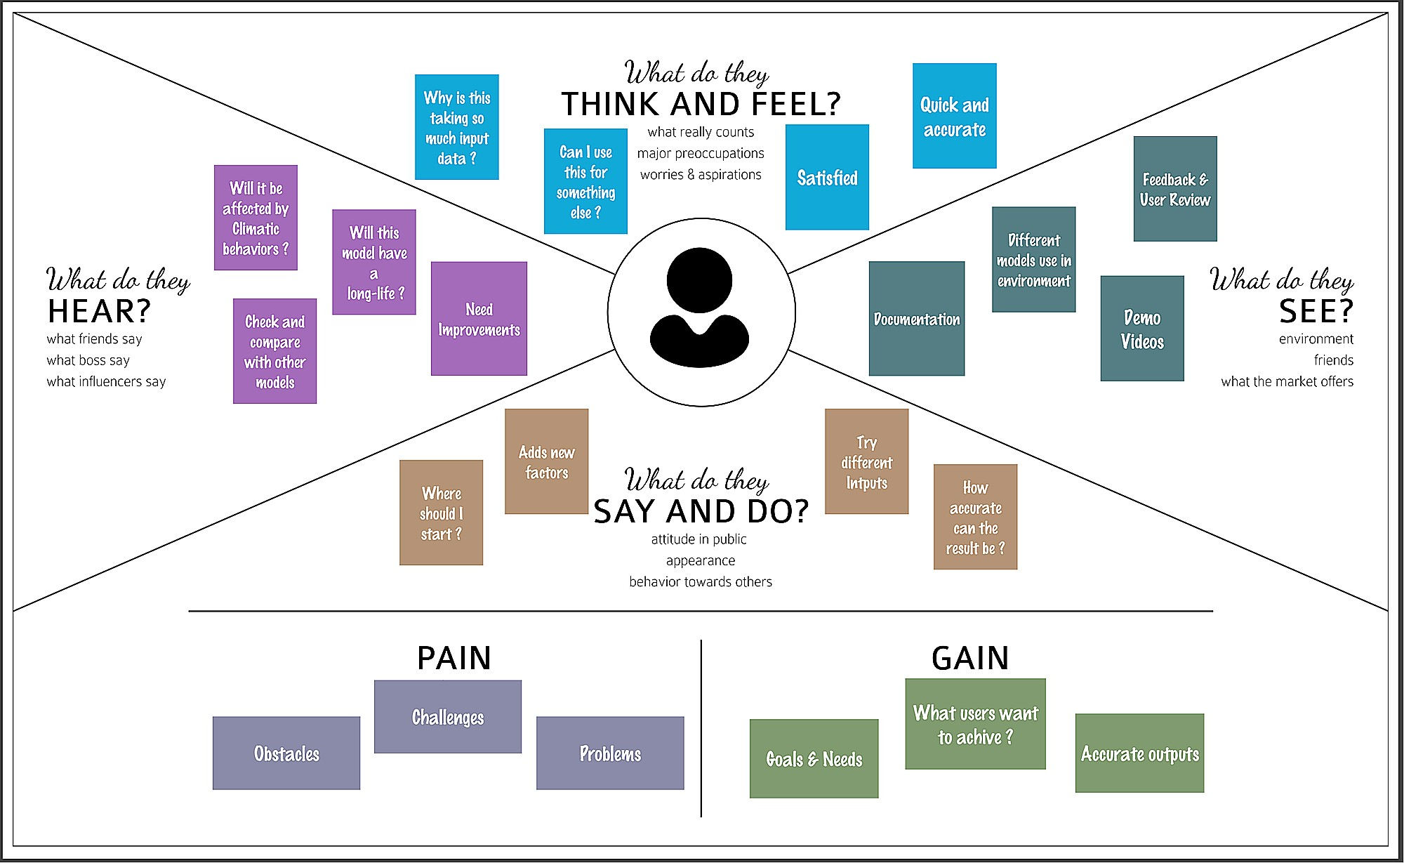

## Ideation & Brainstorming

Brainstorming provides a free and open environment that encourages everyone within a team to participate in the creative thinking process that leads to problem solving. Prioritizing volume over value, out-of-the-box ideas are welcome

and built upon, and all participants are encouraged to collaborate, helping each other develop a rich amount of creative solutions.

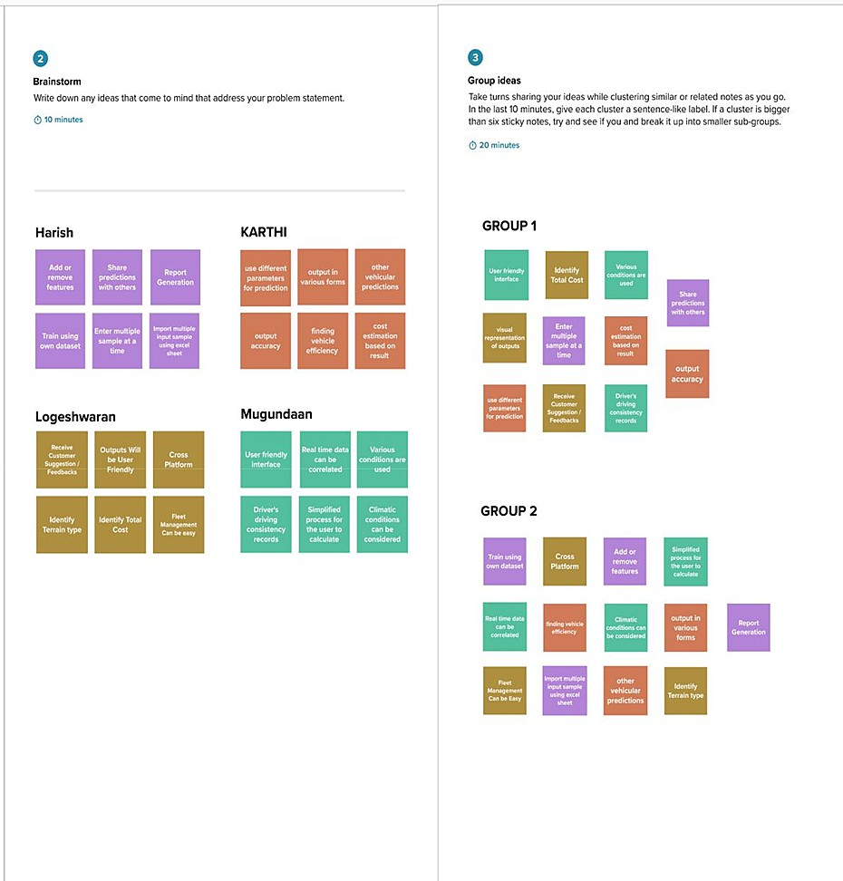

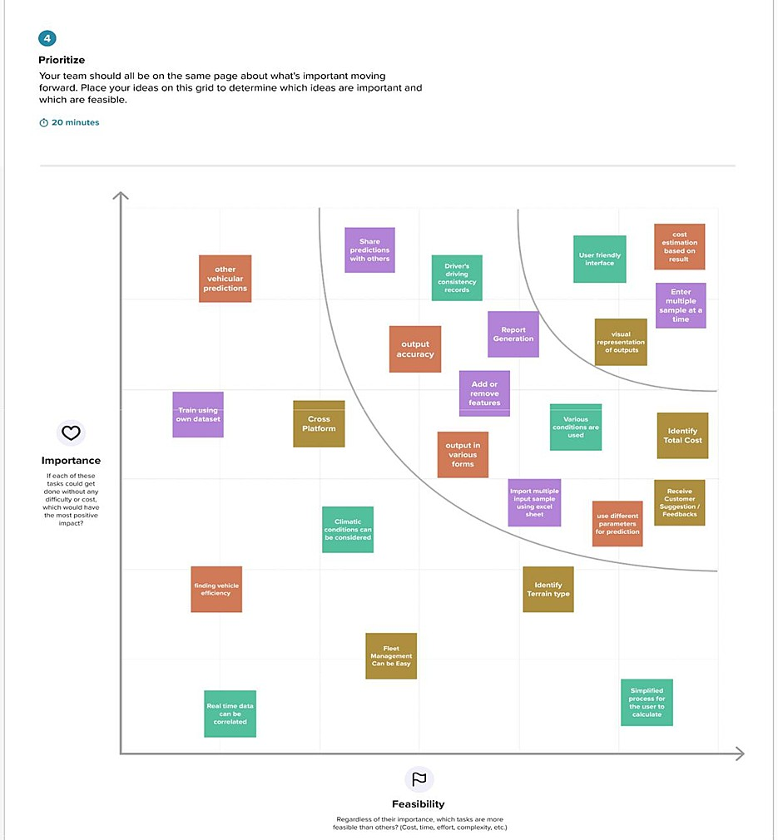

## Proposed Solution

|  |  |  |
| --- | --- | --- |
| **S.No.** | **Parameter** | **Description** |
| 1. | Problem Statement (Problem to be solved) | The problem statement is to predict fuel consumption of modern fleet vehicles using machine learning. A web application needs to be built which is integrated with the ML model. The solution should satisfy the following user requirements:   * User friendly interface * Process multiple samples simultaneously * Provide detailed report |
| 2. | Idea / Solution description | The solution is a mobile responsive web application that can be used in both mobile and computers. Cumulative results of multiple ML models are used to achieve accurate prediction. The website provides a user-friendly interface and accepts multiple samples predicting them simultaneously.  A detailed report can be generated along with the  predicted output. |
| 3. | Novelty / Uniqueness | * Multiple ML models are used to predict the fuel consumption. * Results are generated in various forms. * Users can run multiple samples at a time. |
| 4. | Social Impact / Customer Satisfaction | Fraudulent activities can be prevented in fleet management. Customers are satisfied in all aspects as the proposed solution is developed using multiple ML models. |

|  |  |  |
| --- | --- | --- |
| 5. | Business Model (Revenue Model) | The revenue is generated on subscription basis where large scale data processing and detailed report generation are allowed for only premium  subscription. |
| 6. | Scalability of the Solution | The application can further be extended to provide Application Programming Interface (API) which can be used by third party organizations such as Automobile Manufacturers,  Logistics companies, etc. |

* 1. **Problem Solution Fit**

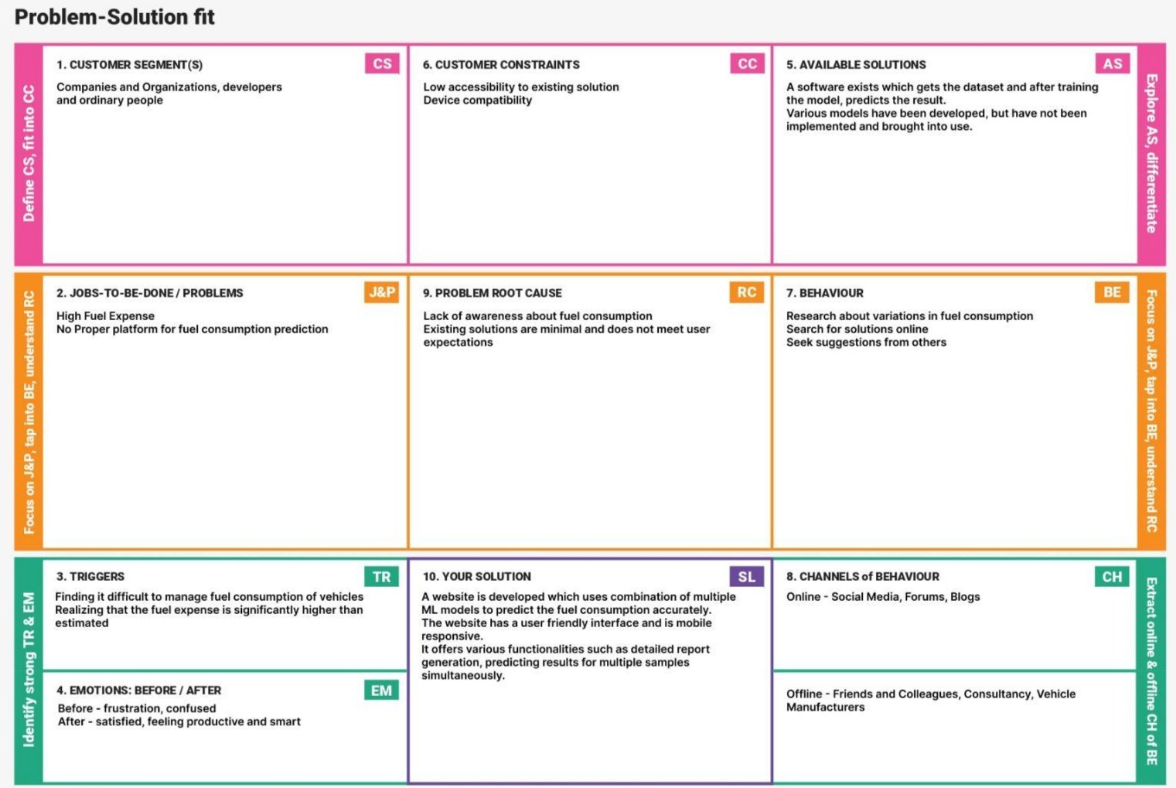

# REQUIREMENT ANALYSIS

## Functional Requirements

Following are the functional requirements of the proposed solution.

|  |  |  |
| --- | --- | --- |
| **FR No.** | **Functional Requirement**  **(Epic)** | **Sub Requirement (Story / Sub-Task)** |
| FR-1 | User Registration/Login | Via Email  Via Phone number |
| FR-2 | User Dashboard | Single Sample Prediction Multiple Sample Prediction  View User History |
| FR-3 | Output Generartion | Visual Representation  Report Generation |

## Non - Funcitonal Requirements

Following are the non-functional requirements of the proposed solution.

|  |  |  |
| --- | --- | --- |
| **FR**  **No.** | **Non-Functional**  **Requirement** | **Description** |
| NFR-1 | Usability | User-friendly interface to facilitate the user with easy processing Model provides visual  representation of predictions |
| NFR-2 | Security | Authentication - user can have his/her own  private dashboard to have sured access |
| NFR-3 | Reliability | The model is capable enough to handle huge volume of data and run multiple samples  simultaneously |
| NFR-4 | Performance | As the model is combination of multiple ML  algorithms, the accuracy is high |
| NHR-5 | Availability | The website is also mobile-responsive and  portable. It requires only basic |

|  |  |  |
| --- | --- | --- |
|  |  | configurations to run on any device. |
| NFR-6 | Scalability | It can be extended further to provide API which can be used by third party organisation such as Automobile  Manufactures, Logistics companies, etc. |

# PROJECT DESIGN

## Data Flow Diagrams

A Data Flow Diagram (DFD) is a traditional visual representation of the information flows within a system. A neat and clear DFD can depict the right amount of the system requirement graphically. It can be manual, automated, or a combination of both. It shows how data enters and leaves the system, what changes the information, and where data is stored. The objective of a DFD is to show the scope and boundaries of a system as a whole. It may be used as a communication tool between a system analyst and any person who plays a part in the order that acts as a starting point for redesigning a system.

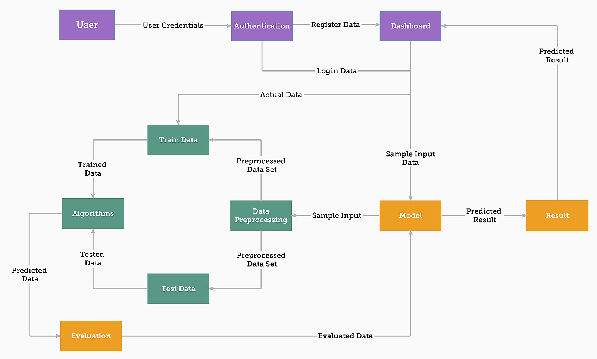

## Solution & Technical Architecture

**Solution Architecture:**

A solution architecture (SA) is an architectural description of a specific solution. SAs combine guidance from different enterprise architecture viewpoints (business, information and technical), as well as from the enterprise solution architecture (ESA).

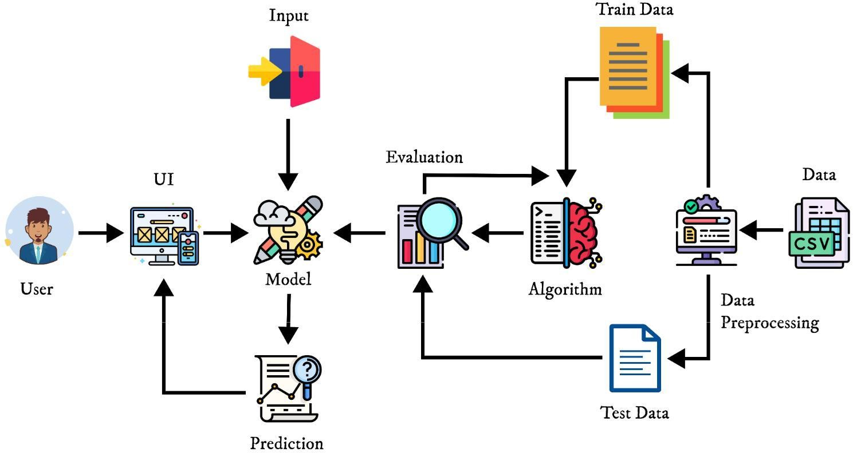

## Technical Architecture:

|  |  |  |  |
| --- | --- | --- | --- |
| **S.No** | **Component** | **Description** | **Technology** |
| 1. | Website | User interacts with the prediction model through website to predict  the fuel consumption | Axios, Material ui, Mobx, Formik,  Yup |
| 2. | Cloud Database | The model is provided with data from IBM cloud databse | IBM Cloud DB, ibm_db(python  package) |
| 3. | API | Used to extend the service to other  application | Flask Application |
| 4. | JWT & Session | It is used for Handling JSON web tokens(singing, verifying,  decoding) | PyJWT, Flask- Session |
| 5. | Machine  Learning Model | This model is developed to predict  the fuel consumption using ML algorithms | Sklearn, Algorithms - MLR |
| 6. | Data processing | Data is pre-processed and used for training the model which is then  used for prediction | Pandas, Numpy, Matplotlib |

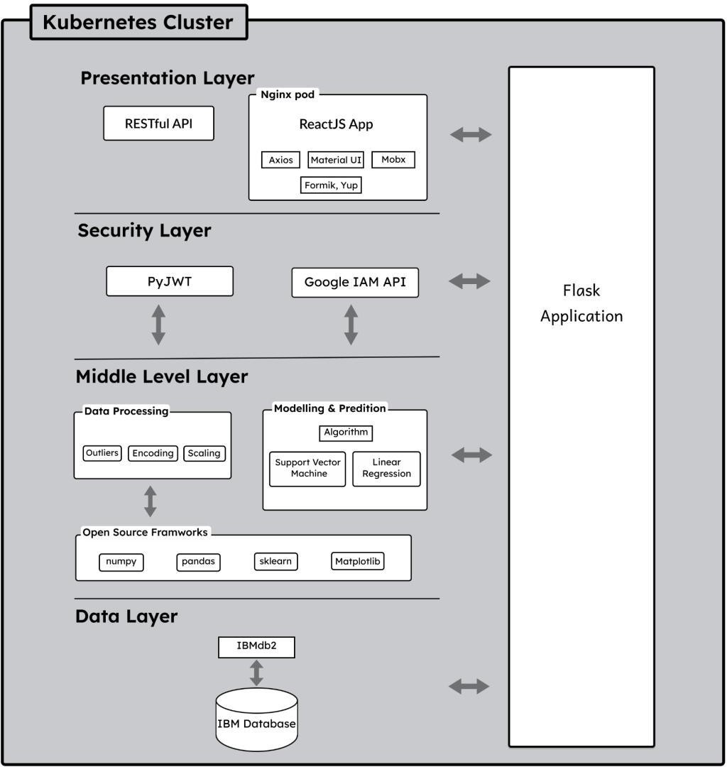

* 1. **User Stories**

|  |  |  |  |  |  |  |
| --- | --- | --- | --- | --- | --- | --- |
| **User Type** | **Functional Requirement** | **User Story**  **Number** | **User Story / Task** | **Acceptance Criteria** | **Priority** | **Release** |
| Customer | Registration / Login | USN-1 | As a user, I can register or login to create a dashboard for my  processing | I can access my account  / dashboard | High | Sprint-3 |
|  | Dashboard | USN-2 | Once I enter the dashboard I can input values for a single sample  prediction | I can predict for single sample | High | Sprint-1 |
| Customer (Organization) |  | USN-3 | Once I enter the dashboard I can input values via excel sheet  for multiple | I can perform multiple sample prediction | Medium | Sprint-2 |

|  |  |  |  |  |  |  |
| --- | --- | --- | --- | --- | --- | --- |
|  |  |  | sample  prediction |  |  |  |
|  |  | USN- 4 | As a user I can get visual representati on of the  prediction | I can have different forms of output | High | Sprint-1 |
|  |  | USN-5 | As a user I can view the detailed report of my  prediction | I can access details of my proccess and  prediction | Medium | Sprint-1 |
|  | Documentation | USN-6 | As a User I can refer to the documentati on for support and  guidence | I can use user manual for guidance | Medium | Sprint- 1,2,3,4 |
| Developer | Settings | USN-7 | As a developer I can allow user to access dashboard's settings to edit the user profile and  update it. | I can use the settings to edit the user profile details and update it. | Low | Sprint- 4 |

|  |  |  |  |  |  |  |
| --- | --- | --- | --- | --- | --- | --- |
|  |  | USN- 8 | As developer I can deploy the model in IBM Cloud using IBM  Watson. | I can deploy the model in cloud and make it available as  a service. | High | Sprint- 4 |

# PROJECT PLANNING & SCHEDULING

## Sprint Planning & Scheduling:

|  |  |  |  |  |  |  |
| --- | --- | --- | --- | --- | --- | --- |
| **Sprint** | **Functional Requirement**  **(Epic)** | **User Story**  **Number** | **User Story/Task** | **Story Points** | **Priority** | **Team Members** |
| Sprint-1 | Registration | USN-1 | As a user, I can register using  email & password | 4 | High | Harish Kumar R |
| Sprint-2 |  | USN-2 | As a user, I can register using  Gmail | 2 | Medium | Karthikeyan S |
| Sprint-1 |  | USN-3 | As a user, I will receive an confirmation email once I registered  for the application | 1 | Low | Harish Kumar R |
| Login | USN-4 | As a user, I can login to my dashboard through email-id and  password | 2 | High | Mugundaan K |
| Sprint-2 | Prediction Model | USN-6 | Once I enter the dashboard I can inputvalues for a single sample  prediction | 8 | High | Logeshwaran K M |
| Sprint-3 |  | USN-7 | I can input values via excel sheet for multi-sample prediction as per the template and  perform prediction | 6 | Medium | Karthikeyan S |
|  |  | USN-8 | As a user, I can get a visual  representation of | 4 | Medium | Karthikeyan S |

|  |  |  |  |  |  |  |
| --- | --- | --- | --- | --- | --- | --- |
|  |  |  | the predicted value |  |  |  |
|  | Report Generation | USN-9 | As a user, I can view the detailed report of my  prediction | 3 | High | Mugundaan K |
| Sprint-4 | Documentation | USN-10 | As a User, I can refer to the User manual documentation for support and guidance | 6 | Medium | Logeshwaran K M |
|  | Deployment | USN-11 | As developer ,I can deploy the model in IBM Cloud  using IBM Watson | 7 | High | Harish Kumar R |

**Sprint 1:**

It consists of several tasks such as  Registration to the website

 OTP confirmation on successful registration  Login to user dashboard

A fresh user who wants to access the website has to register himself/herself to the website by providing the required credentials. A verification OTP will be sent to the user's mail to authenticate. On successful registration a user dashboard will be created to facilitate with website accessing. If a user has already registered to the website then he/she can login directly using the registered mail. This will take them directly to their dashboard.

## Sprint 2:

It consists of tasks such as  Register via Gmail

 Perform Single sample prediction

A user can also register to the website via Gmail which makes the process easier by using existing gmail. Once the user entered into the dashboard he/she can do fuel consumption prediction for a single vehicle by providing the required inputs to the prediction model. The prediction result will also be available on the same page.

## Sprint 3:

It consists of tasks such as

 Perform Multi sample prediction

 Display visual representation of result  Get a detailed report of prediction

This sprint aims to complete Multi sample prediction which is mainly offered for users such as transport and other organisations. The allows users to predict consumption for multiple vehicles at a single stretch. A sample datasheet will be provided to the users where they can enter the values for each input column and

this will be uploaded as an input file(format - .csv) to the prediction model. The result will be displayed in the same page as a table.

Here a user will also get a visual representation of their output via a detailed report. This detailed report will be generated based on the data provided by user and prediction done by the model. The report can be downloaded to facilitate user with more viability.

## Sprint 4:

This sprint covers tasks such as  User manual or guides

 Deploy the model in Cloud

The user will be provided with a manual or guide to help them navigate and access different features of website throughout the process. The manual is prepared in such a way that any user can easily understand the flow of process by looking at the visuals itself.

In addition to model developing we have also deployed the model in cloud using IBM Watson. This can can help user to access the website as a service from IBM cloud.

## Sprint Delivery schedule

|  |  |  |  |  |  |  |
| --- | --- | --- | --- | --- | --- | --- |
| **Sprint** | **Total Story Points** | **Duration** | **Sprint Start Date** | **Sprint End Date (Planned)** | **Story Points Completed (as on Planned**  **End Date)** | **Sprint Release Date (Actual)** |
| Sprint-1 | 8 | 6 Days | 24 Oct 2022 | 29 Oct 2022 | 8 | 28 Oct 2022 |
| Sprint-2 | 10 | 6 Days | 31 Oct 2022 | 05 Nov 2022 | 10 | 05 Nov 2022 |
| Sprint-3 | 13 | 6 Days | 07 Nov 2022 | 12 Nov 2022 | 13 | 11 Nov 2022 |

|  |  |  |  |  |  |  |
| --- | --- | --- | --- | --- | --- | --- |
| Sprint-4 | 13 | 6 Days | 14 Nov 2022 | 19 Nov 2022 | 13 | 19 Nov 2022 |

* 1. **Reports from Jira Sprint 1:**

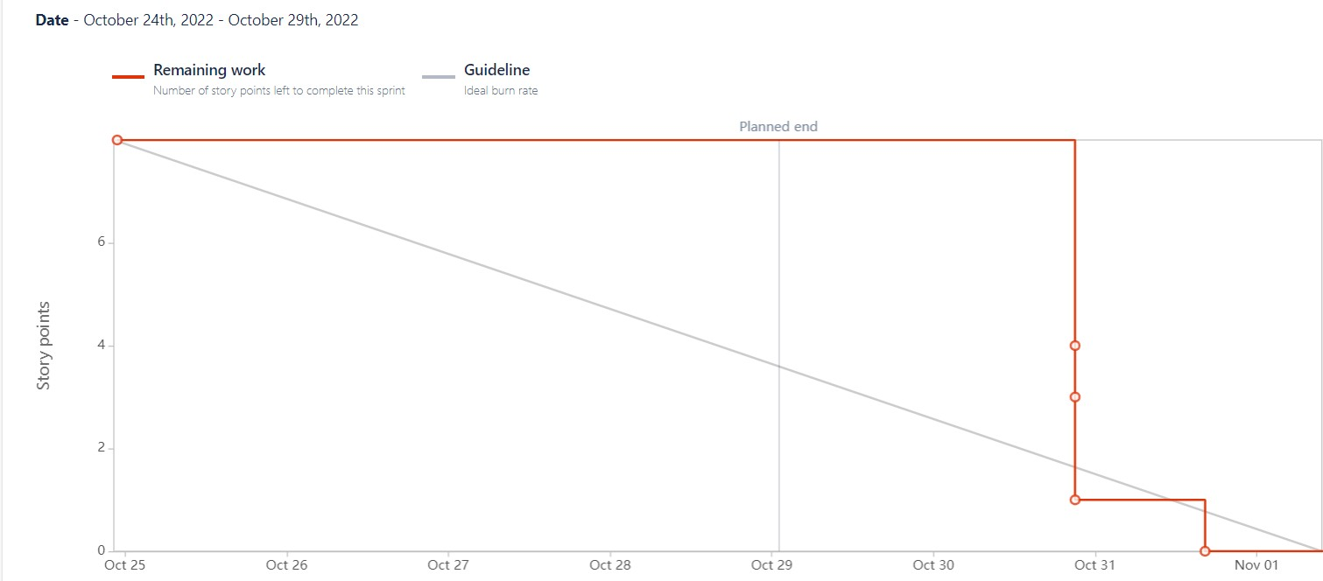

## Sprint 2:

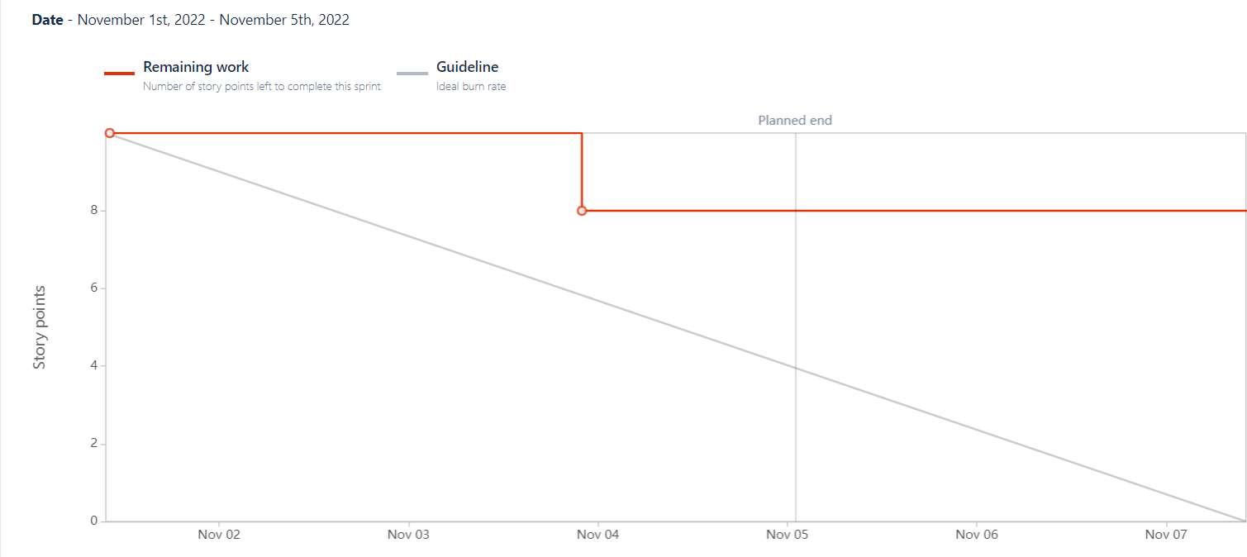

**Sprint 3:**

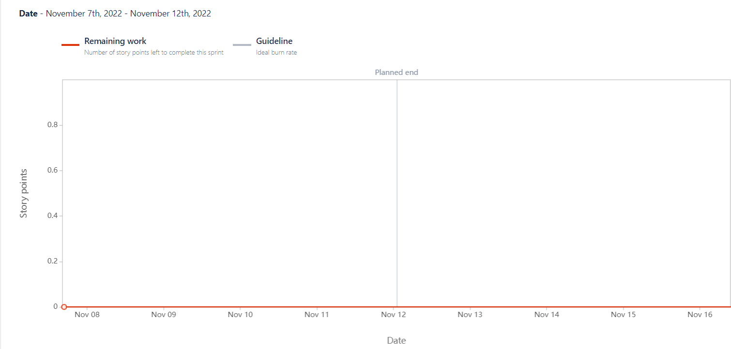

**Sprint 4:**

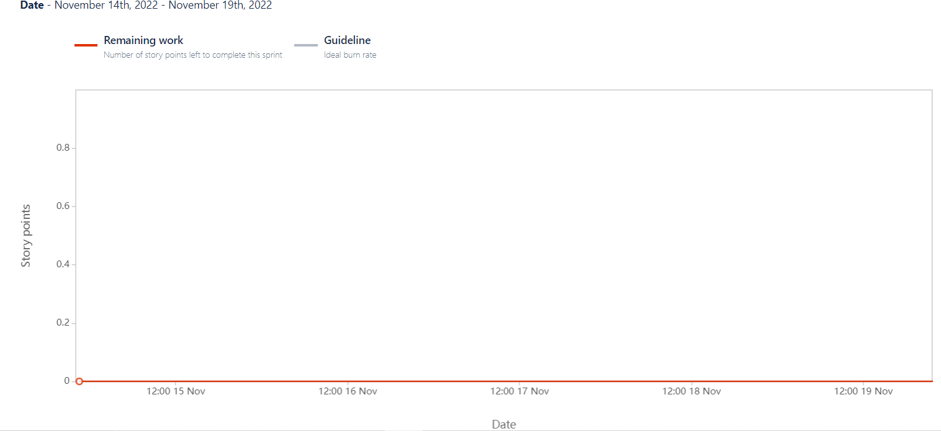

# CODING & SOLUTIONING

The project is intended to develop a website application for fuel consumption prediction. The application provides users with accurate prediction along with few features that users can make use of with great ease.

## User Dashboard

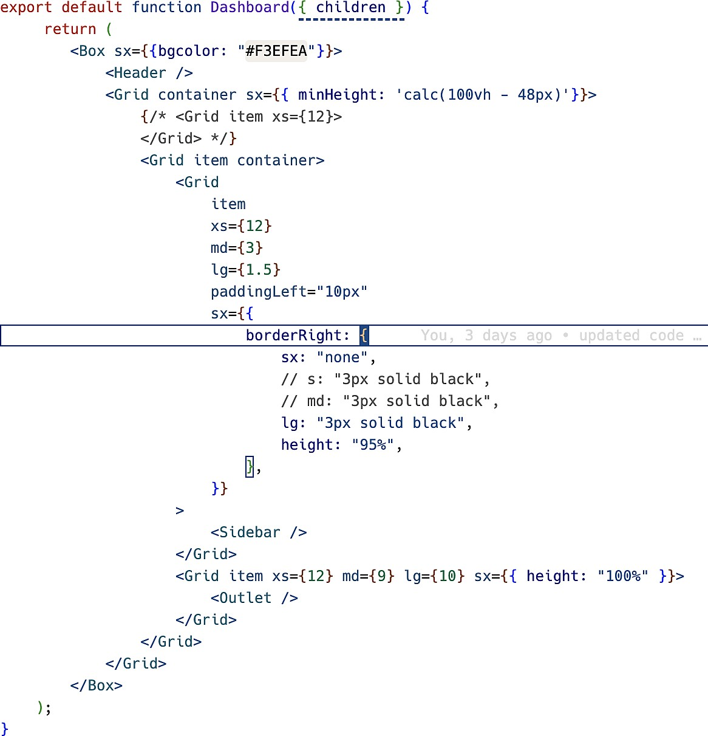To make users convienient to the website an user dashboard has been created where the progress of user will be managed. The user needs to register/login to the website inorder to access the dashboard. This dashboard consists of user profile, prediction tab, prediction history with a simple interface.

## Single and Multiple Sample Prediction

The prediction tab is designed to facilitate two types of uses.

Single sample prediction tab for user to predict the consumption for a single vehicle by entering the inputs manually.

Multi sample prediction tab for user who wants to predict for multiple vechicle simultaneously espeacially for oragnisation with large fleet vehicles. The user needs to upload the input file containing input for each vehicle in a table format. This will deliver them with the same table that of input along with prediction column added at the end of the table.

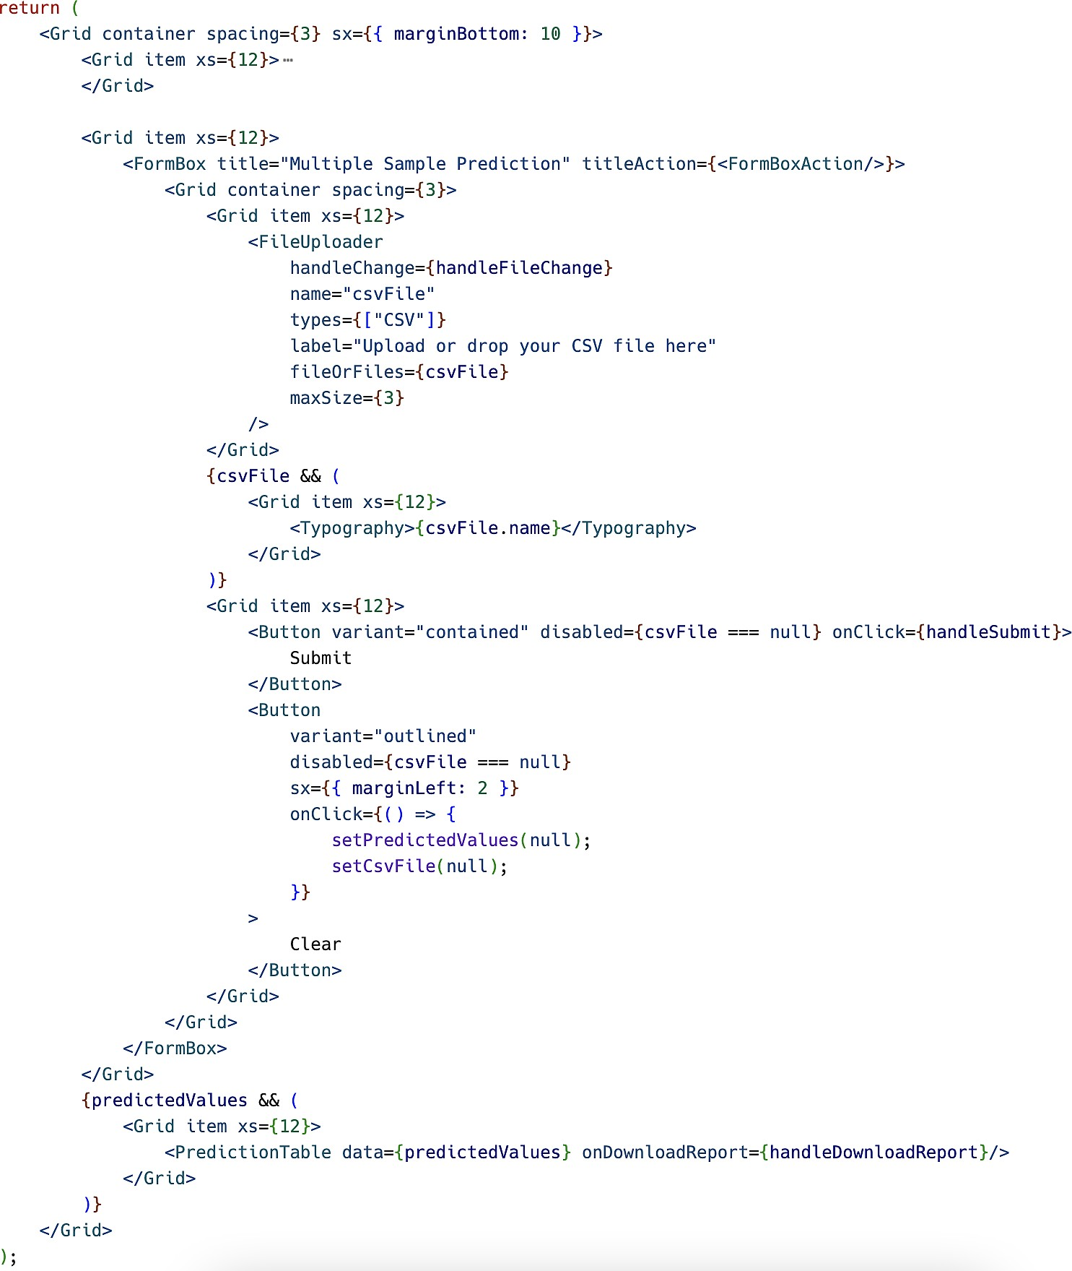

## Prediction History

Inorder to provide the user with better accessibility, we have included a prediction history tab which will allow user to access their recent predictions. This also increases the usability of application. All the data related to prediction will be stored in the database and can be fetched to provide the prediction history.

## Display current Fuel Price

The application will display the Fuel price (in rupees) updated everyday automatically. This will help user to be aware of the current fuel rate variations.

It is also used to provide the estimated cost of the fuel consumption given by the prediction model. It reduces the manual calculation of fuel expenses.

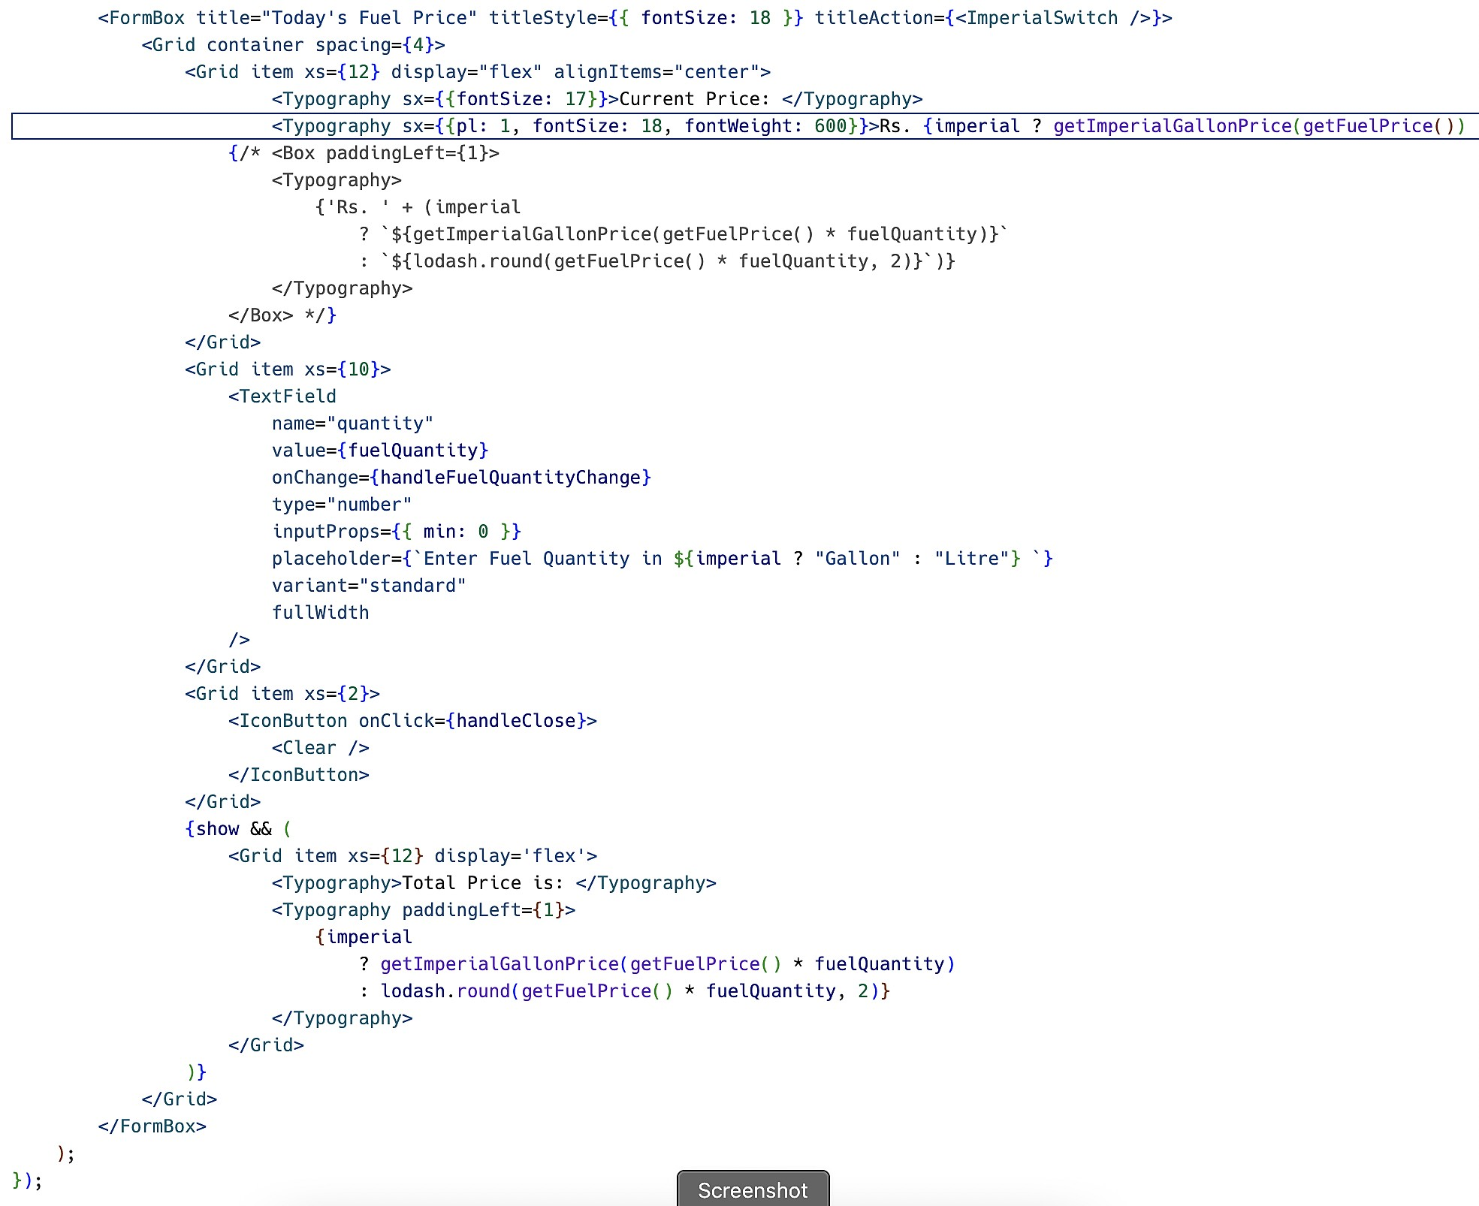

## Detailed report generation

A detailed report of the prediction done by the user will be generated to give a great clarity to the user about the process.

The report consists of

* + - User name
    - Date of prediction
    - Input values
    - Prediction result
    - Fuel consumption estimation(in rupees)
    - Visual representation of Consumption

The report will be available offline where the user can download and make use of it for storing and sharing.

# TESTING

## Test Cases

|  |  |  |  |  |
| --- | --- | --- | --- | --- |
| **TestCase** | **Features** | **Description** | **Steps to Execute** | **Expected**  **Results** |
| LoginPage_FCP_001 | Functional | verify user is  redirected to login page when not  logged in | 1.Enter URL and click  go | Application should  be redirected to login page |
| LoginPage_FCP_002 | UI | Verify user is  able to see the login box | 1.Enter URL and click  go | Application should  show below UI elements: a.email text box b.password text box  c.Login button d.New User?  Signup |
| LoginPage_FCP_003 | Functional | Verify user is  able to see the signup box | 1.Enter Url and clik go 2.Enter valid credential 3.Click on the login  button | Application should  be able to login and redirected to  dashboard page |
| LoginPage_FCP_004 | Functional | Verify user is  able to sign in with google | 1. Enter URL and CLick   go   1. Click on sign in with google button 2. Give access to the   gogle account | Application  Should redirect to google oauth page and be able to allow access |
| LoginPage_FCP_005 | Functional | Verify the error  message is | 1.Enter URL and Click  go | Application should  display an error |

|  |  |  |  |  |
| --- | --- | --- | --- | --- |
|  |  | received if the  email does not exist | 2. Enter the wrong user  credentials | message saying  that user does not exist |
| SignUpPage_FCP_006 | UI | Verify user is  able to see the signup box | 1.Enter URL and Click  go | Application should  show below UI elements: a.email text box b.password text box   1. mobile text box 2. name text box 3. Signup Button |
| SignUpPage_FCP_007 | Functional | Verify user is  able to sign up with credentials | 1. Enter URL and Click   go   1. Enter the user details 2. Click on the signup page 3. Click on register   button | Application should  register the user and send otp if the entered email is valid |
| Prediction_FCP_008 | Functional | Verify user is  able to enter input details for Single Sample Prediction | 1. Enter URL and click   go   1. Click on Prediction Button on Side Menu 3.Click on Single Sample Prediction Tab 4.Enter valid inputs   5. Click on Predict  button | Application should  display a new box showing the predicted value and a button to download the report |
| Prediction_FCP_009 | Functional | Verify user is  able to enter input details for Multi Sample | 1. Enter URL and click   go   1. Click on Prediction Button on Side Menu | Application should  display a table with predicted  values |

|  |  |  |  |  |
| --- | --- | --- | --- | --- |
|  |  | Prediction | 3.Click on Multi  Sample Prediction Tab 4.Download the Sample DataSet   1. Fill the samples of each vehicle in each row 2. Upload the excel sheet in the given field 3. Click on Predict   Button |  |
| Prediction_Report_FC  P_010 | Functional | Verify user is  able to download Single Sample Prediction Report | 1. Enter URL and click   go   1. Click on Prediction History Button on Side Menu 2. Click on Single Sample History Tab 4.Click on the download icon on one   of the rows of the table | A single page  report is downloaded which shows the predicted data along with visual plot |

* 1. **User Acceptance Testing**

## Defect Analysis

This report shows the number of resolved or closed bugs at each severity level and how they were resolved.

|  |  |  |  |  |  |
| --- | --- | --- | --- | --- | --- |
| **Resolution** | **Severity 1** | **Severity 2** | **Severity 3** | **Severity 4** | **Subtotal** |
| By Design | 5 | 4 | 2 | 3 | 14 |
| Duplicate | 1 | 0 | 0 | 0 | 1 |
| External | 2 | 3 | 0 | 1 | 6 |
| Fixed | 1 | 4 | 3 | 2 | 10 |
| Not Reproduced | 0 | 0 | 1 | 0 | 1 |
| Skipped | 0 | 0 | 1 | 0 | 1 |
| Won't Fix | 0 | 1 | 0 | 1 | 2 |
| Totals | 9 | 11 | 7 | 7 | 35 |

## Test Case Analysis

This report shows the number of test cases that have passed, failed, and untested

|  |  |  |  |  |
| --- | --- | --- | --- | --- |
| **Section** | **Total Cases** | **Not Tested** | **Fail** | **Pass** |
| Authentication | 9 | 0 | 0 | 9 |
| Prediction | 2 | 0 | 0 | 2 |
| Prediction History | 2 | 0 | 0 | 2 |
| Report Generation | 2 | 0 | 0 | 2 |
| Profile Updation | 1 | 0 | 1 | 0 |

* 1. **Performance metrics**

# RESULTS

|  |  |  |
| --- | --- | --- |
| **S.No.** | **Parameter** | **Values** |
| 1. | Metrics | **Regression Model:**  MAE - 8.203  MSE - 128.398  RMSE - 11.331  R2 score - 0.721 |
| 2. | Tune the Model | Hyperparameter  Tuning - 0.929  Validation Method - Cross Validation |

* 1. **Screenshots**

# Performance Metrics

# 

**Hyper parameter tuning**

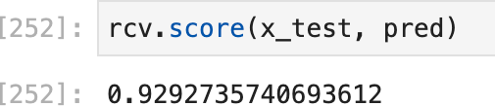

# Validation

1. **ADVANTAGES & DISADVANTAGES**

## Advantages

* + - Easy to use User Interface
    - Mobile responsive UI
    - Supports both single and multi sample predictions
    - Enables users to access the prediction history
    - Provides detailed report

## Disadvantages

* Predicted values are not exact
* Gas types restricted to only two types
* Actual fuel consumption cannot be updated

# CONCLUSION

Fuel has become an indispensable part of our daily life. The world faces a burgeoning demand of fuel which is expected to continue for quite a longtime.

Therefore it is very important to manage the fuel consumption and reduce the expenses on it. The web application developed ensures to provide accurate fuel consumption prediction and update the user to current demand. It also offers various features to users to keep them intact under the growing fuel scenario. The application proves to be worthy for organisation especially for those in transport and servicing. It is also deployed on cloud making it available as a service to users at an affordable rate. Any individual who wants to predict the fuel consumption for a particular trip can access to this application having a easy to use interface. Hence, the web application is released successfully ensuring complete security and usability.

# FUTURE SCOPE

This project can be further extended to provide RESTapi, which a developer can use to access the services provided by the application. This allows a developer to integrate the application's services into another application. Organizations can integrate the application into their products. A subscription based payment model can be added, which restricts the free tier users from using Multiple Sample Predictions and various other features.

# APPENDIX

## Source Code models.py

class User(db.Model):

tablename = 'users'

id = db.Column(db.Integer, primary_key=True) name = db.Column(db.String, nullable=False)

mobile = db.Column(db.String, unique=True, nullable=True) email = db.Column(db.String, unique=True, nullable=False) password = db.Column(db.String, nullable=True)

isActivated = db.Column("is_activated", db.Boolean, default=False) def serialize(self):

return {c: getattr(self, c) for c in inspect(self).attrs.keys()} class UserMultiplePrediction(db.Model):

tablename = "users_multiple_prediction" id = db.Column(db.Integer, primary_key=True) userId = db.Column("user_id", db.Integer,

ForeignKey(User.id), nullable=False)

createdAt = db.Column("created_at", db.Date, nullable=False, server_default=func.now())

class UserSinglePrediction(db.Model):

tablename = 'users_single_prediction'

id = db.Column(db.Integer, primary_key=True)

vehicleNumber = db.Column("vehicle_number", db.String, nullable=True) userId = db.Column("user_id", db.Integer,

ForeignKey(User.id), nullable=False) mileage = db.Column(db.Numeric, nullable=True)

fuelType = db.Column('fuel_type', db.String, nullable=True) distance = db.Column(db.Numeric, nullable=True) roadType = db.Column('road_type', db.String, nullable=True)

averageSpeed = db.Column('avg_speed', db.Numeric, nullable=True) vehicleWeight = db.Column('vehicle_weight', db.Numeric, nullable=False) payloadWeight = db.Column('payload_weight', db.Numeric, nullable=True) predicted = db.Column(db.Numeric, nullable=False)

actual = db.Column(db.Numeric, nullable=True)

userMultiplePredictionId = db.Column("user_multiple_prediction_id", db.Integer, ForeignKey(UserMultiplePrediction.id), nullable=True)createdAt = db.Column("created_at", db.Date, nullable=False, server_default=func.now())

**routes.prediction.py** @app.route('/predict/single', methods=['POST']) @token_required

def singleSamplePrediction(): data = request.get_json()

vehicle_number = data['vehicleNumber'] or 'TN XX YY ZZZZ' vehicle_weight = data['vehicleWeight'] or 0

payload_weight = data['payloadWeight'] or 0 mileage = data['mileage'] or 0

distance = data['distance'] or 0 avg_speed = data['averageSpeed'] or 0 road_type = data['roadType'] or 0 fuel_type = data['fuelType'] or 0

userId = g.get('userId')

predicted = model.predict(

[[mileage, vehicle_weight, payload_weight, distance, avg_speed, road_type, fuel_type]])

fuelTypeString = dataset.inverse_transform('fuel_type', [fuel_type])[0]

roadTypeString = dataset.inverse_transform('road_type', [road_type])[0]

userPrediction = UserSinglePrediction(userId=userId, vehicleNumber=vehicle_number, mileage=mileage, fuelType=fuelTypeString, roadType=roadTypeString,

distance=distance, averageSpeed=avg_speed, vehicleWeight=vehicle_weight, payloadWeight=payload_weight, predicted=ﬂoat(predicted[0]), userMultiplePredictionId=None)

try:

db.session.add(userPrediction) db.session.commit()

return jsonify({'predictedValue': ﬂoat(predicted[0]), 'id': userPrediction.id}), 200 except Exception as e:

db.session.rollback() print(e)

return msgResponse("Something went wrong"), 400

## SingleSamplePrediction.py

<form onSubmit={handleSubmit}>

<Grid container spacing={4}>

<Grid item xs={12} sm={6} md={3} xl={3}>

<ValidatedTextField name="vehicleNumber" label="Vehicle

Number" />

(in Tonnes)" />

</Grid>

<Grid item xs={12} sm={6} md={3} xl={3}>

<ValidatedTextField name="mileage" label="Mileage (Km/l)" />

</Grid>

<Grid item xs={12} sm={6} md={3} xl={3}>

<ValidatedTextField name="vehicleWeight" label="Vehicle Weight

</Grid>

<Grid item xs={12} sm={6} md={3} xl={3}>

<ValidatedTextField name="payloadWeight" label="Payload

Weight (in Tonnes)" />

</Grid>

<Grid item xs={12} sm={6} md={3} xl={3}>

<ValidatedTextField name="distance" label="Distance (km)" />

</Grid>

<Grid item xs={12} sm={6} md={3} xl={3}>

<FormControl fullWidth>

<InputLabel size="small" id="fuel-type-select-label"> Fuel Type

</InputLabel>

<Select

labelId="fuel-type-select-label" id="fuel-type-select" value={values.fuelType} size="small"

name="fuelType"

error={touched.fuelType && errors.fuelType && true} label="Fuel Type"

onChange={handleChange}

>

{mainstore.metadata.dataSetColumnMapping.fuelType.map((fuelType) => {

return (

<MenuItem key={fuelType.name}

value={fuelType.value}>

);

})}

{fuelType.label}

</MenuItem>

</Select>

{touched.fuelType && errors.fuelType && (

<FormHelperText

error={true}>{errors.fuelType}</FormHelperText>

)}

</FormControl>

</Grid>

<Grid item xs={12} sm={6} md={3} xl={3}>

<FormControl fullWidth>

<InputLabel size="small" id="road-type-select-label"> Road Type

</InputLabel>

<Select

labelId="road-type-select-label" id="road-type-select" value={values.roadType} name="roadType"

label="Road Type" size="small"

error={touched.roadType && errors.roadType && true} onChange={handleChange}

fullWidth

>

{mainstore.metadata.dataSetColumnMapping.roadType.map((roadType) => {

return (

<MenuItem key={roadType.name}

value={roadType.value}>

);

})}

{roadType.label}

</MenuItem>

</Select>

{touched.roadType && errors.roadType && (

<FormHelperText

error={true}>{errors.roadType}</FormHelperText>

)}

</FormControl>

</Grid>

<Grid item xs={12} sm={6} md={3} xl={3}>

<ValidatedTextField name="averageSpeed" label="Average Speed

(km/h)" />

</Grid>

<Grid item container xs={12} justifyContent="ﬂex-end"

alignItems="center">

<Grid item>

<Button variant="contained" type="submit"> Predict

</Button>

</Grid>

</Grid>

</Grid>

</form>

## MultiSampleHistory.jsx

export default function MultiSampleHistory() {

const [predictionHistory, setPredictionHistory] = useState([]); useEffect(() => {

apiModal.getMultipleSamplePredictionHistory(function (res, success) { if (success) { setPredictionHistory(res.data); }}); }, []);

return <PredictionTable data={predictionHistory} />;} const PredictionTable = ({ data }) => {

const [pageSize, setPageSize] = useState(10); const handleDownloadReport = (id, row) => {

apiModal.getMultipleSamplePredictionReport(id, function(res, success) { if(success){

console.log(res)

})}

const columns = [

{ ﬁeld: "sample_count",

headerName: "Vehicle Count",type: "number",width: 100, }, { ﬁeld: "created_at", headerName: "Predicted At",type: "number", width: 150,

}, {

ﬁeld: "id",headerName: "",disableColumnMenu: true,sortable: false, renderCell: ({ id, row, formattedValue }) => {

return (

<IconButton onClick={() => handleDownloadReport(id, row)}>

<Download color="primary" />

</IconButton>

);

},

},

];

return (

<> <Paper sx={{ height: "500px", padding: 4 }}>

<Typography variant="h5" fontWeight={600}> Multi Sample Predicted History

</Typography>

<DataGrid rows={data} sx={{ border: "none", }} columns={columns} pageSize={pageSize}

rowsPerPageOptions={[5, 10, 25, 50]} onPageSizeChange={(pageSize) => setPageSize(pageSize)} />

</Paper> </>

);

};

## Modes/Api/store.js

import { observable } from "mobx";

const mainstore = observable({

userInfo: {userId: "", email: "", name: "",mobile: "",token: "",},

metadata: {dataSetColumnMapping: {fuelType: [ { name: "", value: "", label: "", },],

roadType: [ { name: "",value: "",label: "",}, ],},

fuelPrice: { id: "",cityId: "", petrol: "",diesel: "", currency: "",date: "",createdAt: 0 changeText: "",petrolDiff: "", dieselDiff: "",cngDiff: null,cngPrice: null, }, },

userRegistration: { otpToken: "", }); export default mainstore;

## GitHub & Demo link

Github- <https://github.com/IBM-EPBL/IBM-Project-45492-1660730462>

Demo link- <https://drive.google.com/file/d/1bF-VhHB3uagiOIzXY8> QSHevK6dD3hi74/view?usp=share_link

# REFERENCE

1. Bin Zhao Et Al - Fuel Consumption And Traffic Emission Evaluation Of Mixed Traffic Flow With Connected Automated Vesicles At Multiple Traffic Scenarios, [January 2022]
2. Young-Rong Kim Et Al - Development Of A Fuel Consumption Prediction Model Based On Machine Learning Using Ship In-Service Data, [January 2021]
3. Mohamed A. Hamed Et Al - Fuel Consumption Prediction Model Using Machine Learning, [November 2021]
4. Ahmet Gurcan Et Al - Fuel Consumption Models Applied To Automobiles Using Real-Time Data, [July 2022]
5. Sasanka Katreddi And Arvind Thiruvengadam - Trip-Based Modelling Of Fuel Consumption In Modern Heavy-Duty Vehicles Using Artificial Intelligence, [December 2021]
6. Ivković Ivan S.Et Al - Influence Of Road And Traffic Conditions On Fuel Consumption And Cost For Different Bus Technologies, [January 2019]
7. Tony Sandberg - Linköping University, Master’s thesis, Tony Sandberg. Heavy truck modeling for fuel consumption simulations and measurements, [March 2020]
8. Federico Perrotta Et Al - Application Of Machine Learning For Fuel Consumption modeling Of Trucks, [December 2019]
9. Jonas Lindberg - Kth Institute of Technology, School Of Computer Science And Communications (Csc) - Master’s Thesis, Fuel Consumption Prediction For Heavy Vehicles Using Machine Learning On Log Data, [February 2017]
10. A. Nikolaos Peppes, Evgenia Adamopoulou, and Konstantinos Demestichas - vol.4704, Machine Learning Applied to Sensor Data Analysis ed: MDPI: sensors, "Driving Behaviour Analysis Using Machine and Deep Learning Methods for Continuous Streams of Vehicular Data,", [July 2022]